Lab 8 observations
I cannot figure out why the player is not landing on the platforms, both the player and platform hitboxes are rendering, but it is still not catching it.
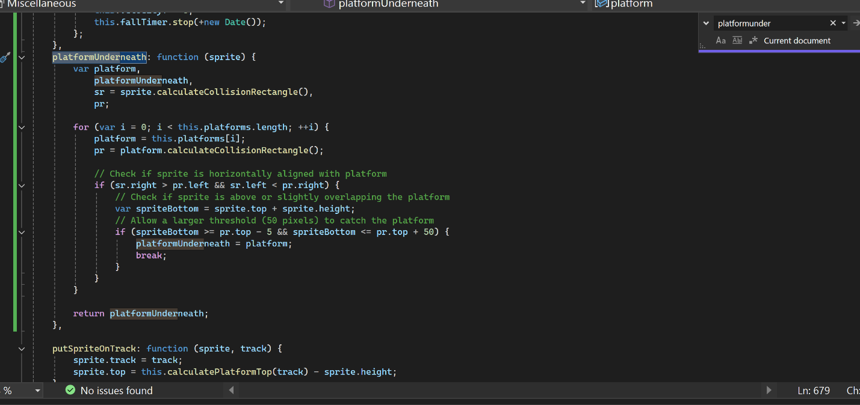

The speed I am getting in the console is 300px/s but I cannot see the console output for it sometimes because I am having issues with the player landing on the platform, so I think that is causing it to not be able to detect the player falling from them. So, I can’t see the vertical speed, the same is happening when trying to get the slow motion to work

